Use the figure below to answer the following questions.

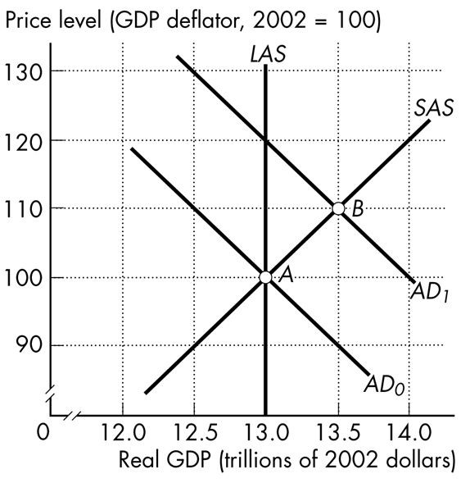

Figure 26.3.5

6) Refer to Figure 26.3.5 above. What type of gap is shown by point B, and how large this the gap in terms of Real GDP?

The type of gap shown at point B is the Expansionary Gap. This is because the actual output of the economy is greater than the potential outcome.

How large:
$13.5 trillions -$13.0 trillions= 0.5 trillions

7) What is the full-employment equilibrium, and what policy action should be taken to return the economy to this equilibrium

13.0 is the full-employment equilibrium. To return the economic equilibrium, one should raise the product's price, so its quantity demand drops until equilibrium is found. If there is a shortage, then raise the price. If there is a surplus, lower the price to increase quantity demand to eliminate the excess.

Table 20.4.4

Quantities | 2013 | 2014
Bananas | 1,000 bunches | 1,100 bunches
Coconuts | 500 bunches | 525 bunches
Prices | 2013 | 2014
Bananas | $2 a bunch | $3 a bunch
Coconuts | $10 a bunch | $8 a bunch

5) Refer to Table 20.4.4 above. The table provides data on the economy of Tropical Republic that produces only bananas and coconuts.

a) Calculate the Nominal GDP in 2013.

Bananas=1000*$2=$2000
Coconuts=500*$10=$5000

Normal GDP= $2000+$5000
=$ 7000

b) Calculate the Real GDP in 2014.

Bananas=1100*$2=$2200
Coconuts=525*$10=$5250

Real GDP=$2200+$5250
=$7450

c) Calculate the GDP Deflator in 2014

Normal GDP in 2014=bananas (1100*$3) + coconut (525*$8)
=$3300+$4200
=$7500

GDP Deflator=normal GDP/real GDP*100
=$7500/$7450*100
=100.67
8) As a result of COVID-19, the Government of Canada has been actively using a Fiscal stimulus policy. Using an Aggregate Supply – Aggregate Demand graph, illustrate the intended impact of the Fiscal stimulus policy on Aggregate Demand. What action with respect to the debt level might the government have to take once the Fiscal stimulus policy is removed?

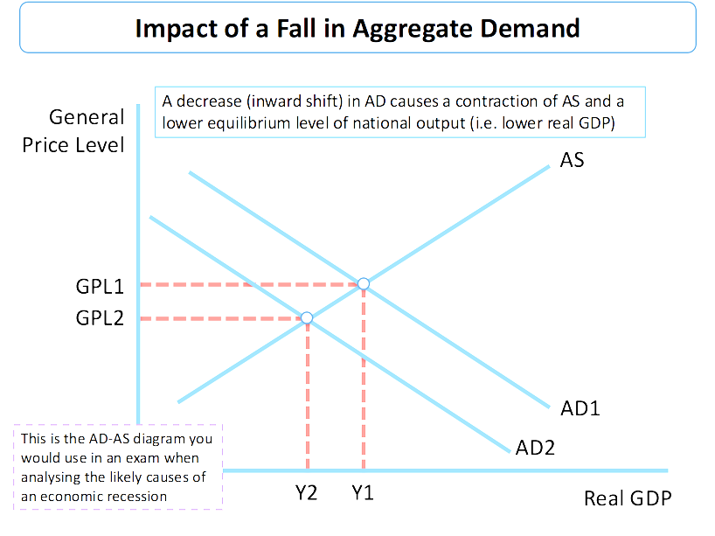

If Fiscal stimulus is removed, the government will expand the economy by either reducing taxes and increasing spending or even both. During inflation, it will raise taxes and decrease spending or both.

